Attendance policy checklist
Working together to improve school attendance (publishing.service.gov.uk)
Refer to pages 11-12, 22, 56 for all policy requirements:

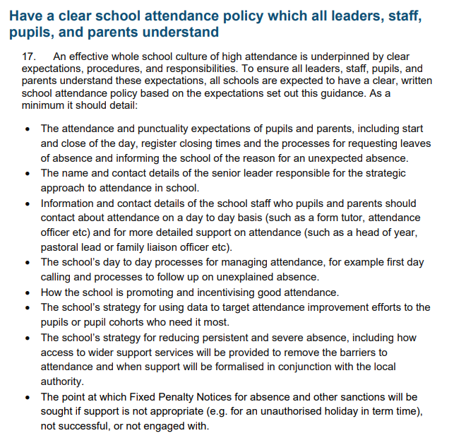
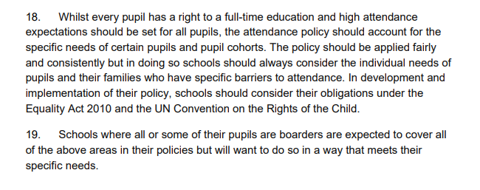
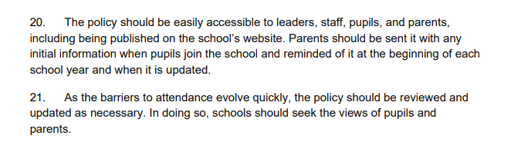

Policy Guidance on Lateness:
