Record significant dates between July – September, and mark them off as they occur. This can include school based events, such as leavers assemblies, and personal events, such as family holidays or celebrations.
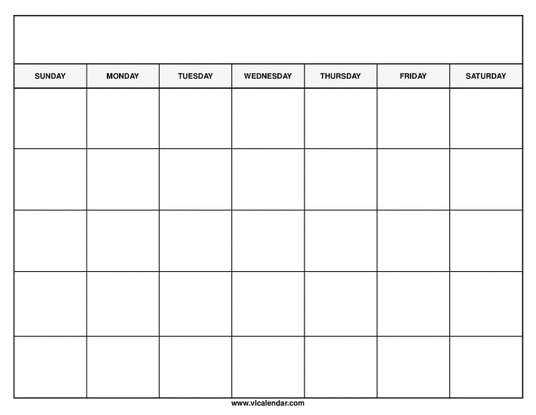
September
August
July

