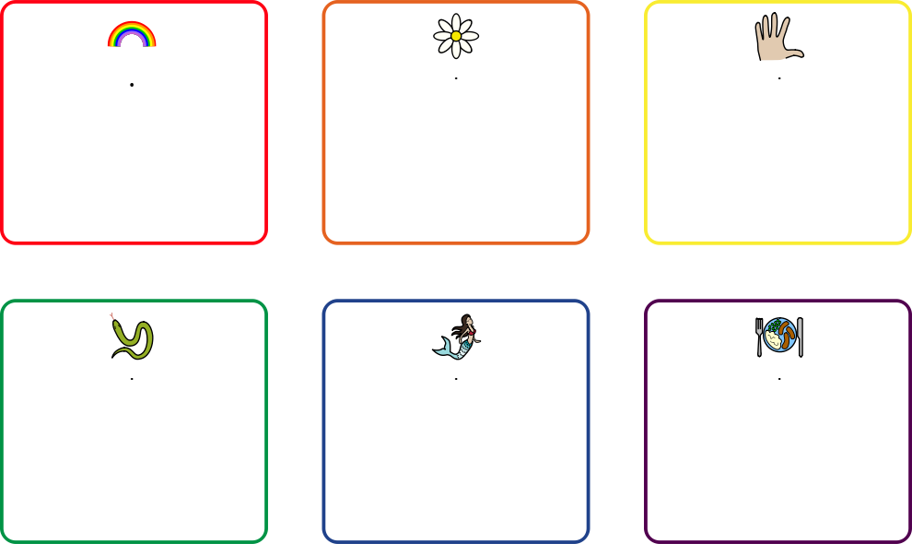

Hand

Place your finger from one hand at the base of your thumb. Breathe in as you draw up your thumb, then out as you draw down the other side. In as you go up your index finger … etc. Work all the way along your fingers and back.

Rainbow

Imagine a rainbow. Start at the bottom of the rainbow on the red line. Breathe in as you trace up to the middle, out as you trace down the other side. Repeat for each colour.

Food

Think about your favourite food. Breathe in deeply, inhaling the scent of your favourite food. Hold for 3, breathe out for 3. Repeat.

Mermaid

Imagine you are a mermaid. Breathe in deeply, and blow out pretend bubbles. Repeat.

Snake

Inhale through your nose for a count of 3. Hold for 1. Exhale through your mouth for a count of 3 making a hissing sound.

Flower and Candle

Imagine a flower in one hand and a candle in the other. Breath in slowly through your nose as you smell the flower. Breathe out slowly through your mouth to blow out the candle. Repeat several times.

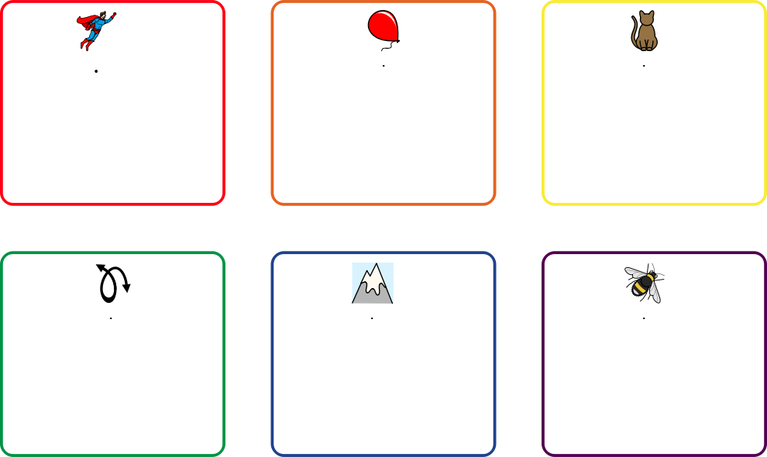

Bee

Breathe in for 5, hold for 3, Breathe out for 3 as you hum quietly.

Mountain

Imagine a mountain range. Breathe in as you go up the mountain, out as you come down the other side.

Infinity

Imagine an infinity sign. Draw round the loop whilst breathing in. When you return to the centre breathe out round the other loop.

Cat

Hunch your shoulders, drop your chin, and arch your back like an angry cat as you breathe in. Drop your shoulders and breathe out as you imagine the cat relaxes.

Balloon

Place your hands on your tummy. As you breathe in, feel your tummy rise, and imagine a balloon inflating. As you breathe out, feel your tummy fall and imagine a balloon deflating.

Superhero

As you breathe in clench your fists and hunch your shoulders like hulk. As you breathe out, punch forwards in a superman pose.