Claim £30 cashback on reusable nappies

Complete the form below and return it to:
Waste Prevention Team, Worcestershire County Council, County Hall, Spetchley Road, Worcester WR5 2NP or email to realnappies@worcestershire.gov.uk

Full name (Mr, Mrs, Miss, Ms) …………………………………………………………………………………………….

Address……………………………………………………………………………………………………………………………………

………………………………………………………………………………………………………………………………………………

Postcode ……………………………………………………Tel number ……………………………………………………….

Email address ………………………………………………………………………………………………………………………

Baby’s date of birth …………………………………… or estimated due date ………………………………….

Terms & conditions:
- Open to Worcestershire residents only;
- Open to new users of nappies only;
Please tick which form of voucher you wish to receive:
Voucher for Bambino Mio discount pack
Voucher for Close Parent discount pack
Voucher for TotsBots discount pack
Love2Shop voucher

Please ensure you have enclosed:
Copy of birth certificate or MAT B1 form if requesting a voucher for the discount packs.
Copy of receipt/online confirmation if requesting Love2Shop voucher.

To be eligible for the voucher you must:
- Live within the county of Worcestershire
- Only make one application per household/family (unless you have twins)
- Have a baby under 24 months old or be expecting
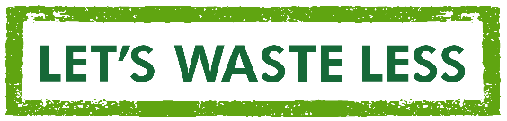
- Love2Shop vouchers will only be issued on production of a receipt or online confirmation which has been issued in the past 6 months
- You also need to be willing to be contacted a few months after you start using your nappies to help us evaluate the effectiveness of the incentive scheme

For WCC use only:

Date form received:
Evidence included: Birth certificate MAT B1

Date voucher issued:

Voucher chosen:
Bambino Mio Close Parent TotsBots Love2Shop voucher

Voucher reference number:

