Guidance for Pupil Conversations

“Children …have a right to receive and make known information, to express an opinion, and to have that opinion taken into account in any matters affecting them…”

See Articles 12 and 13, The United Nations Convention on the Rights of the Child (1989)

Communicating and listening to our young people is integral to our work. To gain a clear understanding of their world, experiences and what it is like to be them means spending time with them, listening to them as well as talking to the significant adults around them who know them best. Please support the young person to gather their views to be shared at the PEP meeting.
We want to hear the voice of the child/young person. We want to know what it is like to be the young person, their views and what they would like to happen. Some of the questions you may wish to ask include;

- What do you enjoy most about coming to school?
- Which lessons do you like the best?
- What is the best thing you have done or achieved at school, so far?
- Which are the lessons or what learning do you wish to get better at?
- What job do you wish to do in the future?
- What activities do you like to do after school? (clubs, team, activities)
- When you are finding something difficult in school, what are the best things an adult can do to help you?
- If you are upset at school, how would you like the adults to support you?
- What things do you like best about your learning?
- What would make you happier at school?

In order to gather the evidence, you are likely to need to speak to the child/young person on more then one occasion, throughout the duration of the term. Other adults who have spoken to the child/young person, may be able to offer insights that have been shared by the young person about their school experience.

We often find young people can be reluctant to come to the PEP meeting itself, so this process is invaluable in order that we are able to understand what we may be able to do to support our young people. There are several tools you could use to act as prompts for conversations, including;

- Regular check ins
- Conversations from the playground
- Three Houses tool (example attached)
- Pupil profile (example attached)
- Make every effort to help children with communication difficulties express their views. Pictorial cards can be used and interpreters if needed.
- Free drawing

- Making a list of favourite things
- Wishes and Feelings game (example attached)
- Feelings dice (example attached)

This is not an exhaustive list. If you have a technique that you can share as an example of ‘good practice’, please let a member of the Virtual School Team know, and we will include it in this guidance document.

Always make enough time to meet with the child/young person. Spending time using a play activity is valuable, fun, will help to build relationships and may prompt the sharing of information that you may not have been made aware of via direct questions.

Remember the child/young person has a right to know what is recorded about their wishes and feelings and who the information will be shared with. Never change the child’s/ young person’s words – say it as they said it. Equally, do not make assumptions about what their drawings may mean – listen to what they say.

The Signs of Safety guidance and the Three Houses tool can be found through this link

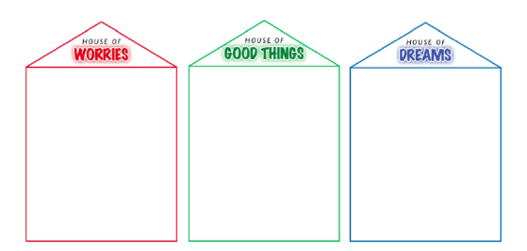

There is a huge variety of templates (lego, football clubs, stars, music, harry potter, wtc.) available to download for free through this link

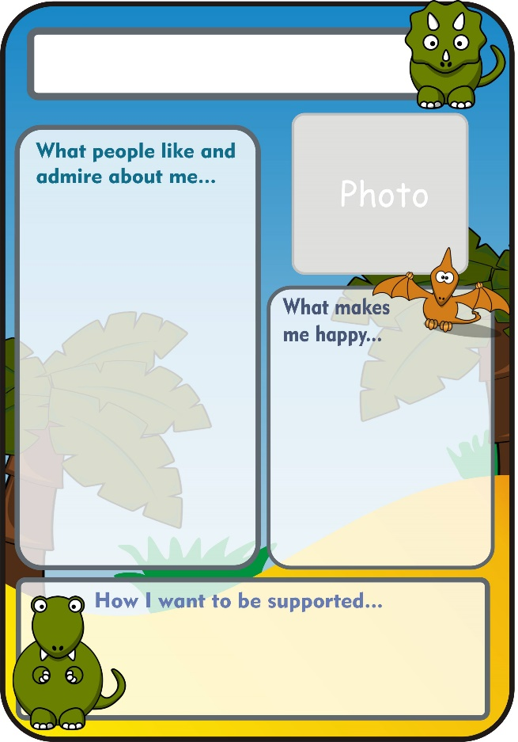

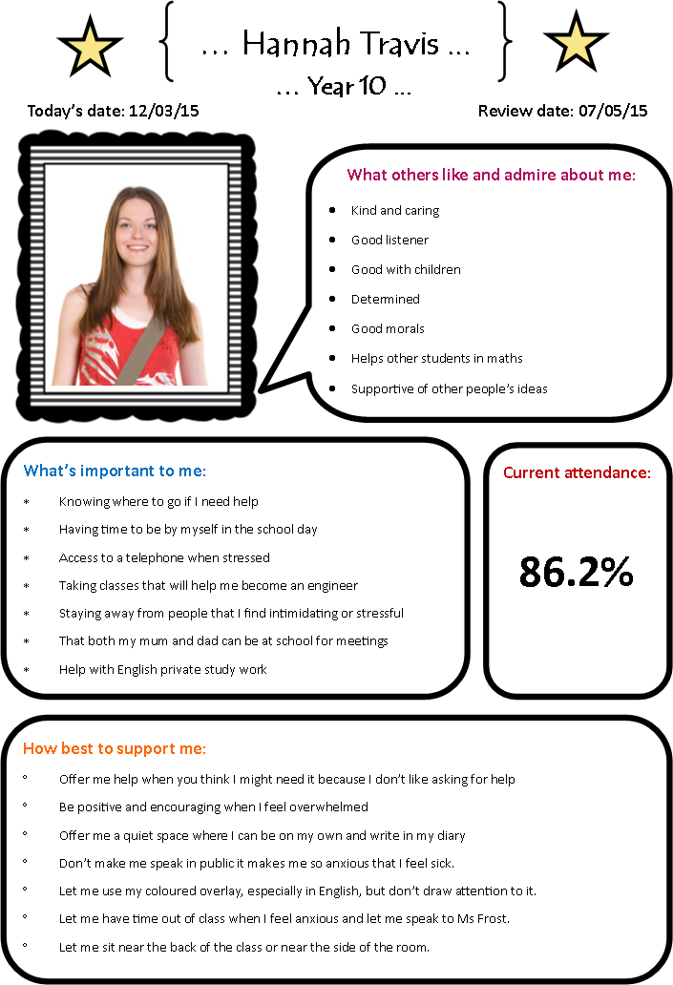

Wishes and Feelings game

The game template can be downloaded here
Instructions for the game
Roll the dice and move your game piece that number of squares. Reading the emotion written in the square and say a time when you have felt this emotion e.g. I feel happy when I am riding my bike.
The game can be for 2-4 players. The first player to get to the end wins

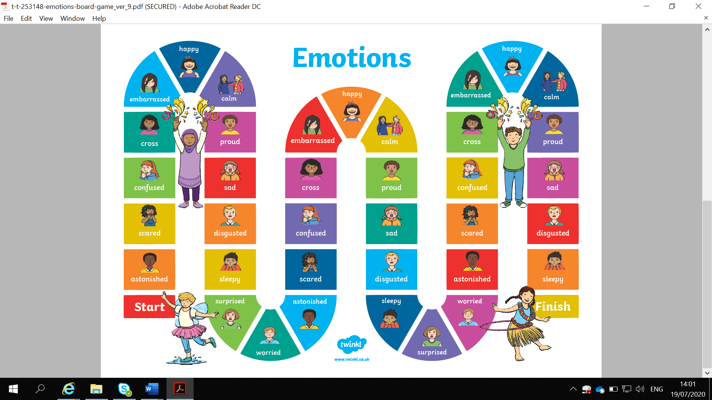

Emotions dice

You can download the template through this link

