NOTICE OF CASUAL VACANCY

EVESHAM NORTH WEST DIVISION
OF
WORCESTERSHIRE COUNTY COUNCIL

NOTICE IS HEREBY GIVEN under section 87(2) of the Local Government Act 1972 that a vacancy has arisen in the office of County Councillor for the Evesham North West Division of Worcestershire County Council.

An election to fill the vacancy shall be held within 35 days (computed in accordance with the Representation of the People Acts) after notice in writing to fill the vacancy has been given to me as the Proper Officer of the Council in accordance with the Local Government Act 1972 by two local government electors for the Local Authority area.
Dated: 09.02.24
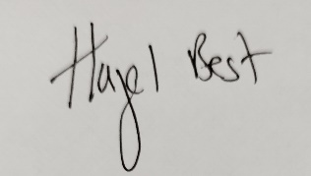
Hazel Best
County Returning Officer (Proper Officer)
hbest@worcestershire.gov.uk

Worcestershire County Council
County Hall
Spetchley Road
Worcester
WR5 2NP

