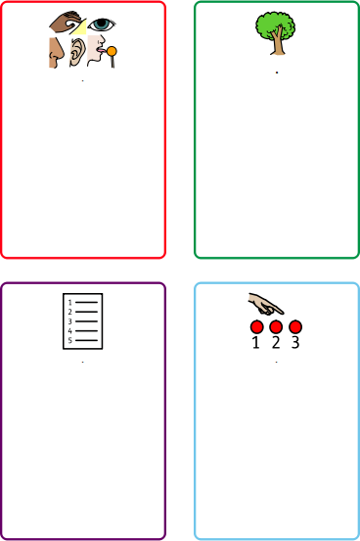

I am a strong tree

* I stand with your feet planted firmly on the ground like the roots of a tree.
* I keep my body tall and straight like the trunk of a tree.
* I place my arms out or above my head like the branches of a tree.
* I breathe in and out slowly like the wind, and gently sway my arms.

Counting

Complete a counting challenge, for example:

* Count back from 98 in 7s.
* Count to 100 in 2s
* Start doubling from 1. How far can you go?
* Count in 3s

Categories

Name 10 items from 3 different categories. Some ideas are:

* Harry Potter characters
* Pokémon
* Movies
* Sports
* Colours
* Cities

5,4,3,2,1 Technique

Name:

* 5 things you can see
* 4 things you can feel
* 3 things you can hear
* 2 things you can smell
* 1 thing you can taste