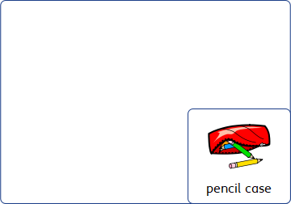

When you arrive at maths you realise that you have forgotten your pencil case.

* How might you feel?
* What should you do?
* Who could you ask for help?
* What might help you in the future?

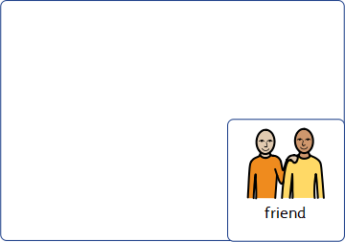

At break time you go to meet your friend at the canteen as planned, but they are talking to someone else.

* How might you feel?
* What should you do?
* Who could help you?

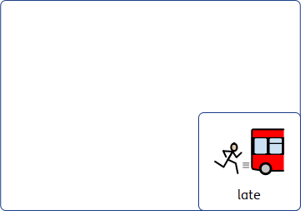

The bus arrives late, and you are late for school. Registration is finished, and the first lesson is about to start.

* How might you feel?
* What should you do?
* Who can you ask for help?
* What could you do differently?



You aren’t sure what lesson you have next, and can’t make sense of your time table.

* How might you feel?
* Who can help you?
* What should you do?

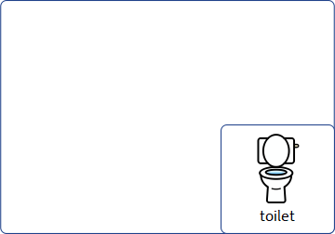

You need the toilet in a lesson. You are worried that you can not wait until break time.

* How might you feel?
* What should you do?

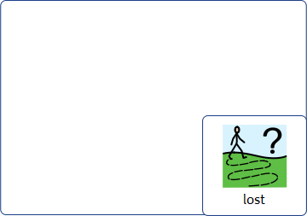

You realise you don’t know the way to your next lesson. The bell is about to ring.

* How might you feel?
* What should you do?
* Who might help you?

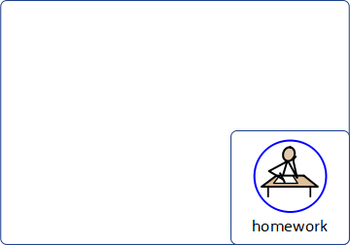

You realise that you have forgotten to do you homework. It is due in the next lesson.

* How might you feel?
* What should you do?
* What might help you in the future?

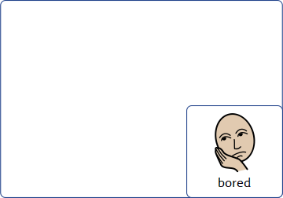

You feel bored in the lesson. You haven’t been listening to the teacher, and they ask you a question.

* How might you feel?
* What could you do?
* What might help?

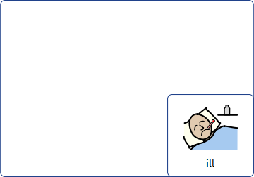

You start to feel ill in the day. By the end of break time you feel very ill.

* What should you do?
* Who can help you?
* What should you do?

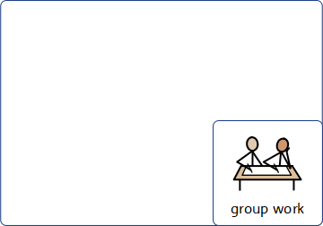

You have been asked to work in a group to do a science project, but you aren’t sure what to do.

* How might you feel?
* Who could help you?
* What should you do?

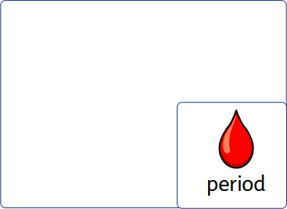

You start or come on your period whilst you are at school. You don’t have any sanitary products with you.

* How might you feel?
* Who could help you?
* What should you do?

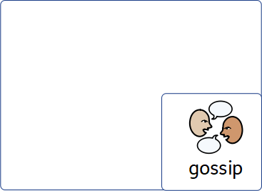

You overhear some gossip about you that isn’t true.

* How might you feel?
* What should you do?
* Who can help?

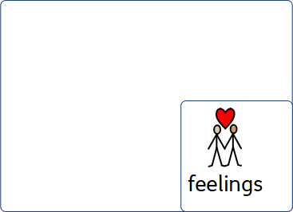

You have feelings about someone in your class. You start to think about them all the time.

* How might you feel?
* What should you do?
* Who can help?

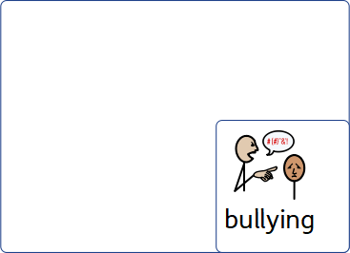

Some people in school are calling you unpleasant names.

* How might you feel?
* What should you do?
* Who can help?

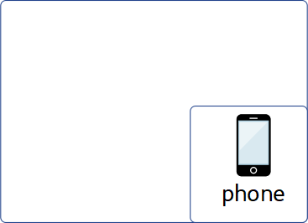

One of your friends has asked you to hang out after school, but your phone battery is flat.

* How might you feel?
* What should you do?
* Who can help?