

*Insert picture of new school here*

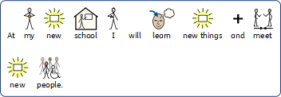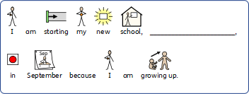

*Insert picture here*

*Insert picture of teachers / or topic pupil might be looking forward to .*

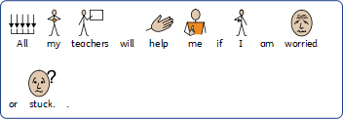

*Insert picture of new uniform here*

*Insert picture of teacher here*

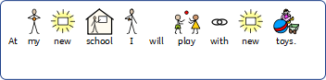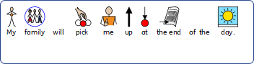

*Insert picture of new toys, in particular , something the child might really be looking forwards to.*

*Insert picture of family here.*